HOW TO IMPROVE YOUR FRONT CRAWL SWIMMING TECHNIQUE

Of the three disciplines, swimming is by far the most technical to master. This is largely because we are land based animals, and for the simple reason that we weren’t given the characteristics of fish. The medium in which the action takes place (water) is unforgiving. This is largely due to the fact that water is nearly one thousand times denser than air. The harder you hit it the harder it hits you back.
The most successful swimmers are almost robotic and are able to hold their technique and maximise propulsive movements whilst at the same time
minimise resistive forces acting against the body. The ability to slip, slide and glide through the water with apparent relaxation is paramount.

Propulsion

Swimmers actually move more effectively through the water by making sculling or sweeping (curved line path) movements with their hands. By changing the path of their hand during the propulsive movement, a smaller mass of water is moved as the hand searches for ‘still’ water. The use of the hand in curved or elicitable sweeping movements allows the swimmer to use ‘lift’ forces to create propulsion and forward movement.

Swimmers use this ‘lift’ force to create forward movement by using their hands like rotating propellers, as they sweep their hands through the water creating lift and so propulsion.

In order to produce effective propulsion we encourage you to try the following:

A good ‘catch’ point - This is where propulsion begins after the arm enters
the water. It is important not to start the pulling action too fast but to press
with the fingers and have a firm wrist. This allows the hand to feel for the
pressure of the water.

High elbow position – The hand stays still, the elbow moves over the hand as the shoulder medially rotates allowing the swimmer to skull their hand laterally and vertically.

To use sweeps of the hand – lots of sculling drills to encourage holding the ‘pressure’ throughout the propulsive effort.

Acceleration – encourage swimmers to start each pull slowly, feel the
pressure and then accelerate through the propulsive effort.

Streamlining

The shape and orientation of the body in the water will determine how much
resistance will be encountered. The more tapered and slender the shape the
better. A tapered shape disrupts the water less, presents less frontal mass and allows water molecules to fill in almost immediately after the body passes through the water. Fish obviously have the ideal shape for moving through water.
Unfortunately, compared to fish the human body shape is poorly designed for this purpose. Furthermore, swimmers change position constantly as they swim presenting a variety of shapes to oncoming water flow.

Technique and streamlining help to reduce drag as speed increases and good pace will leave the swimmer with more energy to overcome drag towards the end of a race.

Body Position

The body should be flat, horizontal and streamlined as possible, just below the surface. The head should be in line with the body, in a relatively natural position ie not lifted or looking down, with the eyes looking diagonally forward and down (at an angle of around 45o) and the water breaking the forehead just above eyebrow level. It is essential that the head should remain still and central during the stroke cycle to prevent excess turbulence, except when breathing. The shoulders and hips should be high in the water, with the feet just below the surface. Rotation around the long axis is required to allow effective propulsive movements of the arms and legs and to aid in the facilitation of breathing action.
It is important to encourage full rotation of the body so that the hips and shoulders roll together and the swimmer avoids the problem of what is known as ‘fixed’ hips.
Correct body rolling technique can make the frontcrawl action much more
streamlined and efficient. This rolling motion not only makes the stroke look more effortless, but it actually does make it easier to perform. The body must be kept horizontal in the water as much as possible when viewed from the side and a vertical/ straight line when viewed from above or behind.

Leg Action

The leg action and head position are two of the fundamental components to an effective body position in the water. The main role of the leg action is to balance the propulsive movements of the arms and maintain a streamlined body position.
Different variations of the kick are possible. For example two beat, four beat, six beat and two beat crossover kick. Swimmers will almost always naturally use the kick which is best suited to them.
Triathletes who compete in the sprint distance events tend to favour a higher beat leg kick, whilst Ironman competitors tend to adopt a two or four beat kick due to the reduced energy costs associated with them. Ankle flexibility is of great importance to the effectiveness of the kick both for propulsion and balance.

Downbeat
The kick is initiated from the hips and the thigh and sweeps downwards as the
foot passes the hips during the previous upbeat. The knee and ankle joints should be relaxed with the foot held in a planter-flexed position (toes pointed). The whip-like action towards the end of the downbeat results in the legs snapping straight.
This whip-like action brings the largest area of the feet in contact with the water pressure in a backwards and downwards direction. Some in-toeing can occur during this phase.

Upbeat
The leg should be extended and straight with the foot in a relaxed position and rebound upwards as the previous downbeat is completed. The thigh initiates the up kick and the knee flexes slightly. The foot is planter flexed prior to the commencement of the downbeat. A good coaching tip is to keep the leg fairly straight on up beat to avoid excessive bending of the knees.
The kick should be maintained within the body depth (about 30-45cm). If this
range is extended, then unnecessary resistance can occur.

Limb Path
It is important that the kick is not entirely on a vertical plane but rather it moves with the hip rotation created by the body roll. The kick will move through a diagonal and vertical, direction.

Variation
The cross over kick where one foot passes over the other in response to individual breathing is acceptable provided that it ensures a streamlined and straight body position and eliminates lateral movement.

Arm Action

The main propulsive force of the frontcrawl is derived from the arms and is an
alternating action with continuous movement.

Downsweep
The hand sculls outwards and downwards to the catch point. The hand resists
the pressure of the water and the shoulder medially rotates to raise the elbow
(high elbow) the hand then continues to sweep outwards and downwards.

Insweep
The elbow increases in flexion and the pitch of the hand turns inwards. The hand sweeps inwards and acceleration of the hand increases.

Upsweep
The hand pitch adjusts again to a backward and outward position. The fingers
point down until the final stages as the hand sweeps up, out and back.
Acceleration continues. When the hand passes the hips, the wrist rotates and
releases the water. The hand is now in position for exit.

Sweeping Movement
When viewed from below, the hand should follow the ‘S’ shape pull pattern. The severity of the ‘S’ will depend on individual characteristics such as strength.

Recovery
This should be made with high elbows and no tension in the hands or arms. The fingers should point down and the hand should start to reach for entry once the arm passes the head.

Breathing

Breathing in swimming has to be taught and for the non-swimmer can be quite
challenging to master. The head should rotate gradually as the arm is pulled
back. Breathing should be at the end of the propulsive phase of the arm with the head as low as possible. In fact, the swimmer should breathe in the bow wave created by the head. The head should turn at approximately 45o to the side, so the swimmer is looking at the poolside wall, and return smoothly and without delay following breathing and the face should be back in the water before the arm passes the head during the recovery phase.

Bilateral breathing is encouraged even if the swimmer does not use it in a race. A percentage of training should be done in this fashion. Bilateral breathing encourages the return of the head to the central position and is good for stroke balance and control.
The swimmer should breathe out gradually underwater with full exhalation at the end of the pulling phase of the arm.

Timing

Different timing of the kick to the arms is possible. Two beat, four beat, six beat and two beat crossover kicks are used. The six beat kick is generally more propulsive but also uses more energy and many distance swimmers swim with reduced kicks and then increase the kick rate towards the end of a race. The important thing with kicking and timing is that it must balance the arm stroke and keep the body in straight alignment so that less resistance is created. Whatever timing is used, the kick should balance the sweeping action of the arm.

Notes
Tip 1 Good kicking ability is important when swimming frontcrawl. A good
strong kick improves stroke balance. The legs have to be extremely
conditioned as they work hard throughout the entire race distance. If
the legs fatigue too early in the race, stoke balance is lost and
resistance is increased. For these reasons coaches should include
fast kicking sets regularly in training using kick boards

Tip 2 Hand paddles are excellent for improving technique and developing
strength and local muscular endurance in the upper body. Care
should be taken when using paddles with younger swimmers due to
physical developmental issues, the paddles should be only slightly
larger than the surface area of the hand for these individuals. The
coach should carefully plan and monitor paddle work to avoid injury
to shoulders. Larger paddles can be used with more senior triathletes,
who are strong enough to handle the extra pressure encountered.
Paddles which just cover the fingers are also available and are ideal
for teaching correct entry position and sculling actions.

Tip 3 Frontcrawl swimmers need to work on the ability to use bilateral
breathing. In Triathlon it is useful to look both ways and be aware of
the competition. The main advantage of bilateral breathing is that it
helps to balance the stroke, as the head always returns to the centre
whilst the body is encouraged to perform full body roll on both
breathing and non-breathing sides. Furthermore, it reduces the
possibility of developing muscle imbalances occurring, which can be
associated with uni-lateral breathing (breathing to one side only).

Tip 4 Always train for the race model, taking into consideration stroke
count, stroke rate, pace and tactics. If in a Triathlon event you are
required to start fast and then settle onto a steady pace, you should
practice this in training sets.

Tip 5 Remember active rest will improve recovery rate. So gentle
swimming to aid recovery should be incorporated between hard
training efforts.

Frontcrawl Skill Development Drills

Swimmers should continuously endeavour to swim with perfect technique in
training to ingrain the correct movement pattern. Drills are vital to help isolate
particular skills. If correctly performed, they will have a beneficial transfer effect to the full stroke. Some key drills to develop frontcrawl are outlined below:

Kicking Drills
The kick can be performed with a kick board using ‘deep’ and ‘shallow’ kicking
technique. This improves the feel for the water pressure on the feet. The kick can also be performed on the front, back and side without a board and with good streamlining. Vertical kicking in deep water with the hands out is also good for testing kick efficiency and developing kick power and strength.

Super Slow Swimming
Performance of the full stroke in slow motion without pause requires concentration and control. The swimmer has to balance and stabilise and can ‘feel’ stroke patterns and problems. This is an excellent method of refining the frontcrawl stroke.

Drag fingers Freestyle
The swimmer swims normally but has to trail the finger tips in the water during
recovery phase of the arm stroke, this is a particularly good drill for teaching high elbow recovery and encouraging body roll.

Head-up Freestyle
The swimmer performs the normal freestyle stroke but with the head up. This is good for working on the entry position of the hands and the slide forward to catch. A ‘high’ elbow is essential and the swimmer can check entry and elbow position during the swim.

Fist Swimming
Swimming with the hands closed takes away the effects of using the ‘paddle’.
When alternated with normal hand position the swimmer is reminded to hold the pressure on the hands, and emphasise pulling with the arms. This particular drill can be used to develop the execution of the power phase in a straight line and corrects any glide away of the hands after entry

Single Arm Swimming

The arm on the non-breathing side is extended and held in front. This allows the swimmer to work on the breathing side of the stroke. This drill encourages a good turn of the head when breathing and the swimmer and coach have the
opportunity to check the timing of the head turn relating to the arm stroke on the breathing side. A kick board can be used in the outstretched arm to aid support and balance, therefore allowing full concentration on the breathing and the stroke cycle.

Use of Fins

All swimmers should have a pair of fins. They should not be too long - top
swimmers often cut them down to size. Fins are good for improving ankle
flexibility and generally offer support when performing drills. This extra support
enables the swimmer to concentrate on the training requirements of the drill.
However, the swimmer should not become dependent on the fin and so should alternate technique work with and without fins. Speed work with fins is also beneficial as they enable the swimmer to move faster than their race pace and so provide muscular contractions at speed which is good for the central nervous system and muscle fibre recruitment.
Swimming
“The 3 most important things to becoming a successful swimmer are: technique, technique and technique.”
Of the 3 disciplines, swimming is by far the most technical to master. This is largely because we are land based animals, and for the simple reason that we weren’t given the characteristics of fish. The medium in which the action takes place is unforgiving. The harder you hit it the harder it hits you back. The most successful swimmers are almost robotic and are able to hold their technique and maximise propulsion whilst at the same time minimising resistance in the water.
In order to become a faster, more efficient swimmer, triathletes must train two aspects: fitness and skill. Fitness improves by spending an appropriate, accumulated amount of time working the various training zones to achieve the desired training adaptation, i.e. swim faster. Thus, many endurance athletes believe that spending endless hours pounding out lap after lap in the pool is the only solution. It is certainly one piece of the puzzle. However, in all types of training, but especially swimming, the concept of economy needs to be addressed. Economy simply means how efficiently the body uses oxygen during exercise. How well a multi-sport athlete picks her/his parents plays a role, but skill development is essential. Because the medium of water is so dense, compared to air, a triathlete must work harder to propel her/himself along. Streamlining the body, i.e. learning a more hydrodynamic position, reduces drag forces allowing the swimmer to move through the water more efficiently. By combining improved fitness, both aerobically and anaerobically, with serious time spent on skill and body position improvement throughout the training phase, the athlete achieves the greatest speed during the swim.
Where do skill and body position drills fit in the workout? After a 10-minute warm-up, spend 10-20 minutes on drills - while the triathlete is still fresh - to enhance the development of new, more efficient movement patterns. One goal is to decrease the number of strokes per length of the pool, indicating more length per stroke. Count the number of strokes per length at various times throughout the training week (2-4 times per week) to look for improvement. Always alternate a skill drill with an easy swim to integrate the aspect of the drill into the whole stroke. Remember, the fastest, most accomplished swimmers in the world do drills everyday!
Here is a series of drills to improve technique. Start and end with a strong, relaxed 25 or 50, count strokes, record time, but it is not a sprint.
1) The “X” to the pencil: A balance and body position drill. Place 3-5 kickboards (start with 3, add more to increase challenge) between the ribs and hips, lay flat in the prone position in the water. The idea is to put the body in a dolphin-like, downhill streamlined position. A snorkel may be used to maintain position. Start with arms and legs in an “X” position, stretched long. Hips are in posterior pelvic tilt, head, shoulders and upper chest are pressed down toward the bottom of the pool. In very slow, controlled movements, move limbs lightly over the surface of the water into the pencil position – arms and legs parallel. The movement should take 5-10 seconds, hold and balance in pencil for another 5-10 seconds maintaining perfect, streamlined posture: head and shoulders pressed down, shoulders squeeze head and ears, arms and legs stretch long in opposite directions, back flat, pelvis in posterior tilt. Practice for 2-5 minutes.
2) Kick: Easy 50 incorporating this new, hydrodynamic body position, same as pencil, arms over head, fins may be used.
3) Kick on side: Lay on side in water, bottom arm straight and stretched out overhead, top arm pressed flat on top hip. Press head and shoulders down towards the bottom, head is submerged (simply lift head to breathe) top hip is on the surface. Repeat on other side.
4) Add hip rotation: Kick on side, switch sides at halfway point, generate rotation from hips and legs. 2x50.
5) Sidekick and rotate: Lie on side, after 6-10 kicks on side rotate with a long, strong arm pull to the other side for 6-10 kicks. Designed to facilitate bilateral rotation. 2x50.
6) Sidekick, rotate with 3 long strokes: Same as above, use 3 long strokes then rotate to opposite side, repeat. 2x50.
7) End test: repeat 25 swim as at beginning.
This series of drills will take longer at first, but spend the time on it, the effort will pay off. Take the time to develop the skills to slice through the water while expending the least amount of energy.

Another really good way of incorporating drills into a swim session is a method called “Shaping and chaining”, which essentially means doing a drill, followed by the same distance normal stroke. This enables you to focus solely on one aspect of your stroke, and then to try and put that into practice when swimming normally. It is also a good recovery swim workout. (FC = Front crawl)

Warm Up
400m FC Surge every 2nd length. Every 4th length BC

Main Set:

All on 30 secs recovery.
Non drill 100’s breathing to weaker side

100 FC
100 FC catch up
100 FC
100 FC Fists
100 FC
100 FC Single arm FC
100 FC
100 FC Kick
100 FC
100 single arm front crawl
100 FC
100 FC drag fingers Bilateral every 3
100 FC
100 FC Super slow swimming

Cool Down

150 mix of BR/ BC

Open water swimming sighting and navigation tips so you only swim the actual race distance

Swimming in a triathlon can be an unpleasant experience. Your months of training become disrupted by dozens or hundreds of other triathletes churning in the water all around you, and the mental focus that was so simple during a pleasant lap lane swim at the local swimming pool becomes almost impossible with the sudden chaos. As if that wasn't difficult enough, visibility sucks, there is no wall to push off, and the 10 degree drop in water has completely taken away your breath.

So... what's the best way to deal with this difficult and often exasperating aspect of multi-sport? The answer returns to the one of the most important concepts in racing - train the way you race. Here's some key open water swimming drills that should help. I'm *hoping* that you already plan on, or have already performed, open water swimming. But you can often use your open water swim time to work on the subtle nuances of training that may give you a slight edge during the race, such as...

Starts

- If starting waist deep, push off the bottom with your feet, dolphin dive forward, then propel yourself with one powerful whip kick before transitioning into 10 powerful, sprint-speed strokes.
- If starting with a beach run, enter the water in a sprint, dive forward, grab the bottom of the surface (sand, rocks, sticks, etc) with both hands, and then pull forcefully forward, up, and out of the water.
- Once at the surface, take one strong stroke, breathe once, then transition into 10 powerful, sprint-speed strokes.
- Glide back to the starting position (for either start) and repeat 8-10 times.

Sighting

- Practice sighting by turning your head slightly forward either before or after taking a breath.
- Sight after your breath, as there is more time for the water to clear your goggles, thus improving visibility, and less drag from pulling your head directly forward and out of the water.
- When sighting after a breath, you are also more likely to rely on peripheral vision, which will also reduce drag.
- Practice sighting off buoys or other non-moving objects in the water.
- Remember, when in a group of swimmers, these types of sighting marks may not be visible.
- You should also practice sighting off landmarks such as highly visible homes, buildings or other structures on the shore.
In an actual race, you should be choosing these landmarks beforehand, probably while warming up your swim before the start.
A great drill involves choosing 3-5 landmarks, located in different positions along the shoreline or in the water.
Begin by swimming towards and sighting one landmark (sight every 3-10 strokes).
  - Change direction to another landmark after 30-50 strokes.
  - Decide beforehand the order in which you will change direction (i.e. white house, to hotel, to orange buoy, to island).

Turns
- Since you have no pool wall to push off during the "turn" in an open-water race, you should be practicing tight and efficient changes of direction.
- Depending on the race course, you may end up performing up to 4 or 5 turns around a buoy or other non-moving object in the water.
- You should be practicing to use these pace changes to your advantage.
  - Choose an object in the water to practice turns.
  - When approaching the turn, you should transition to one-side-only breathing with every stroke.
  - The side you breathe on needs to be facing whatever object you are turning around (another sighting drill).
  - Try to cut the turn as close as possible, which may require you to use short, choppy strokes.
  - Practice transitioning from a tight, choppy turn back into a long, relaxed glide, as you would do in the race.
  - Go for 8-10 turn repeats.
These three drills will give you something to practice during your open water swims, rather than just jumping into the water and swimming for an hour. Remember, the more practical and race-focused your training becomes, the better triathlete you will be.

Navigation
Can you swim in the right direction when there is no line painted on the bottom? Most of the articles I have read on open water swimming deal with this issue by telling you to look up every few strokes. Practice in a pool. Try lifting your head up and looking at the end of your lane. Lift your head at different times during your stroke and see what feels most comfortable. With that accomplished, you have tackled the most important part of navigation in open water. That is really all you need to be able to do, although there are refinements to help you speed up and make it easier.
Refinements:
- Looking up slows you down and tires you out. If you can stay on course, you will be much better off looking up every 20 strokes as opposed to every 6 strokes. But that is a big "if." Not looking up may speed you up, but that doesn't do much good if you start swimming in circles. The classic solution to this is to practice swimming a length of the pool with your eyes closed. The lane ropes will quickly make it apparent in which direction you naturally veer. Work to straighten out your stroke.
- Know where to expect the buoy (I'll use the term buoy, even though you may end up using some other landmark) when you look. It is a whole lot easier to find the North Star if you start by looking generally north. Likewise, it is a whole lot easier to spot a buoy or some other target if you generally look in the right direction and know where to expect it. During swim practices in the pool, I look at the pace clock in the middle of swims. Because I am too far down the pool by my second breath off the wall, I get only one chance to read it. In order to get a good reading, I need to know where I expect to see the second hand.
- Don't look for too long. If you don't spot your marker (buoy) quickly, take another stroke and look again then. Or you may have only gotten a glimpse of the buoy before you had to put your face back in the water. But this should help you spot it more quickly the next time you look. In choppy or rough water, you may be in the trough of a wave in one stroke, making a buoy impossible to see. But two strokes later, you may be on the crest and able to see for hundreds of yards. Note also that even though you may be on the crest of the wave, the buoy may be in a trough. Oh well, it is better to keep swimming in the direction where you think the buoy is located than to stop until you sight it. Although lifeguards swim with their heads up, we don't have to. A lifeguard's target is much more likely to disappear under the water than a big orange buoy (and have greater consequences, too).

- Follow others. If you are swimming with others, and they appear to be swimming in a straight line, just follow them. But even though they will probably not intentionally veer off course, you should still check periodically.
- Find things to the side that you can use as markers. The Windsor triathlon Swim can be made easier with knowledge of tactics beforehand, which make it quite easy navigationally. On the way up you breath to your right and stay as close to the boats as possible. On the way back use the current by swimming in the middle of the river.
- Use your imagination. There are lots of things around that can help you stay in a straight line without looking up too often. I have used the direction that the rays of sunlight are entering the water to help me stay in a straight line. It certainly isn't perfect, but if it allows me to look up only every 20 strokes instead of 6, it is worth it.
- Don't make big adjustments to your position. If you find yourself quite a ways to the side of the course, change your direction to slowly move back. Remember that the shortest distance from your current position to the next turn is a straight line, no matter where you are. Don't bother swimming straight back to the other swimmers before heading for the next turn; just go for the next turn. You really do not swim much further if you gradually move away from the shortest path and then gradually move back. On an out and back 1.5K swim, you can swim over 40 meters to the side on each leg of the swim, and still swim only an additional 10 meters for the entire swim.

Racing with Others

Racing in open water is not quite the same as just swimming in open water. There are lots of other people around. Do you feel comfortable swimming in the midst of 400 flailing arms and legs? Do you prefer having a little space around you? Keep this in mind during the swim. You almost always have the ability to control how large of a pack you are swimming in. If there are too many arms and legs, move to the outside of the course. I recommend the outside of the course over the inside of the course because of turns. At turns, everybody bunches up as close to the buoy as they can. If you are on the inside, you must work your way into that group in order to swim around the buoy (rules generally frown upon swimming to the inside of the turn buoy). If you are on the outside, you can remain just to the outside as everybody else fights to get within touching distance of the buoy.

Although there are advantages to be gained from drafting other swimmers, you have to be careful in doing so - there are some pitfalls also. When I am drafting someone else, I often notice that my stroke is much choppier as I am struggling to stay in the proper position. If the swimmer is the same speed as me, I find this choppiness just makes me more tired without any additional speed. Occasionally, I will find a swimmer or group of swimmers who I can draft, but I probably spend most of my time in open water races looking for open water where I can stretch out my stroke and cruise. Don't convince yourself that you have to draft just because it is faster; it may not be worth it, so examine each situation.

Race Start (finding/creating space)

Take a handful of spaghetti (uncooked is much less messy) and hold it so all the noodles are resting vertically on the table. (If you are at the office, you can go to the supply cabinet and use a handful of pens as a substitute) They can all be contained in a pretty small circle on the table. Now let them all fall over in the same direction. They are now all over each other and take up much more space on the table. Now imagine a whole bunch of swimmers/triathletes standing on the beach or treading water behind the starting line. They are contained in a pretty small area. Now sound the starting horn and what happens? They all go from being vertical to being horizontal and, just like the spaghetti, are now all over each other. No wonder we always get mercilessly kicked and elbowed at the beginning of races; there just isn't enough room for everybody until after we start to spread out.

If you don't want to be a part of all those flying arms and legs, then plan your escape route before the race starts. Don't start in the middle of the front. Start in the the back, where nobody else will really want your space in the water. The only trouble is that as people get tired after the initial sprint, you will have to navigate through them (or over them, but I don't think Miss Manners would approve). Another option is to start near one side or the other. You can always just swim a little further to the outside to get away from the elbows, yet there aren't as many people to swim through after they tire from their sprint.

If you want to mix it up with the other swimmers, then be prepared to do a little fighting to maintain your space. A bigger, more forceful kick is one method of getting a little more room. The splash acts as discouragement for those around you. Even if they are not afraid of getting kicked, I don't know of many swimmers who like to take a breath while getting splashed in the face. Another trick that is not too obnoxious is simply to make your pull a little wider and hold your forearm close to vertical. This allows you to use your forearm to keep other swimmers a slight distance to your side.

Waves/Swells

For the purposes of this discussion, I will distinguish between waves (or swells), breakers, and chop. Waves travel in one direction and make you go up and down. Breakers are what result when waves reach shallow water. Breakers crash over your head and try to grind you into the ground. Chop is the result of lots of little waves with no apparent direction to them. Imagine putting 100 kids in a pool with no lane ropes or gutters - the end result is what I would call chop. It is also what you often get in windy conditions.

Every body of water has waves and chop. Modern pools do an amazing job at keeping them to a minimum; large bodies of water do not. Remember all those stroke drills you have done in the pool, teaching you to keep your fingers just above the surface on the recovery and to have a nice smooth entry into the water? You can forget them in wavy choppy water. In rough water, if you keep your fingers just above the surface of the water, then you are quite likely to have an unexpected wave come along and cause your hand to enter the water below your shoulder. This is not ideal! In order to allow a reasonable stroke, you need to have a much higher recovery with your hand in open water.

Get it out of the water and in the air quickly. Then when it comes time to put it back in the water, get it quickly from being well above the water to being in the water. The less time your hand spends at the water surface, the less likely it will be affected by waves and chop.

And since waves generally move in the same direction (the wake from a boat is an exception), imagine what will happen if the waves are coming from your right and you can only breath to the right. Unless you happen to have a set of gills, you probably will not be too comfortable. This is one good reason to learn bilateral breathing.

Breakers

For some people, breaking waves are loads of fun. For others, they are a source of terror. If you are in the latter group, then think twice before entering any ocean swims. It is best to become comfortable with breaking waves before having to negotiate them in a race. Waves break because of interaction with the bottom. Bigger waves also affect water motion at a deeper depth, so they interact with the bottom and break further from shore. Watch it sometime: the little 6 inch waves break right on the shore and the big waves break quite a ways from shore.

For the most part, the maximum size of the waves is pretty predictable. Watch them for a few minutes and see how big they are and how far out they break. It would be very unlikely that they will change much in the time it takes you to do your swim. This is important because the best place to swim is directly affected by where the waves are breaking. Between the breakers and shore, a lot of water goes in and goes out with a lot of force. Most people with a functioning self-preservation instinct do not just stand around in this area. And even if they try, they tend to get moved around by the water.

Just beyond the breakers, the swells are quite large, and make swimming quite difficult. Besides, if one slightly larger than usual wave came in, you might not be past its breaking point. Involuntary bodysurfing is not the same as open water swimming. As you get further beyond the breakers, the swells are not nearly so large, so swimming becomes much easier. Beyond a certain distance, going further beyond the breakers doesn't affect the size of the swells at all, it only gets you further beyond the breakers and further from shore.

So the trick is to get beyond the breakers as quickly as possible, swim around out there, and then get from the breakers back to shore again as quickly as possible. When getting past the breakers or back into shore, the biggest thing to remember is not to fight the water! It will win. Don't be afraid to let the water push you around a little - it is better to give a little than to break. There are lots of tricks that can help keep your body intact when getting past the breakers.
- Go under/through the wave. I list this first because I think it is probably the most useful technique. Just before a wave breaks, you can dive under the wave or through the vertical wall of water and go through the wave. You can actually just stand there (preferably sideways so it doesn't have as much to push on) and let the wave go around you. If the wave has already broken, don't try to go through the whitewater that results. That is another good way to become an involuntary bodysurfer. Instead, go under the wave. All that whitewater is headed for shore on top of comparatively calm water down below. Find that calmer water before the whitewater finds you. It will still be pretty turbulent, but it won't be headed for shore and trying to take everything along with it. Once the turbulence subsides, the wave has passed and you can come to the surface again. Just remember to keep some air in your lungs in case you get to the surface just before another wave reaches you. If that happens, get a quick breath if you can, dive back under, hope you can get a real breath after this wave and try to stay calm and relaxed. It doesn't take much water to provide protection. When I used to work at the ocean, I often found myself in a situation where I was standing knee deep water with a 5-6 foot wave approaching. I couldn't outrun it back to shore, and I couldn't fight it, so I flattened myself on the sandy bottom as well as I could and waited out the turbulence. I'm alive today, so we have at least some anecdotal evidence that it works reasonably well.
- Go over the wave. If the wave is small, then you are probably still in shallow water and can jump over it. If the wave is not very small and is just beginning to break, then you can float up and over it. You can probably imagine what happens if you try this and the wave has really started to break - you find yourself halfway back to shore when you finally surface.
- Force yourself through the wave. This is useful only for waves that are too big to jump over but still too small to dive through or go under. The idea is to turn sideways and lean your shoulder or hip into the wave as it breaks. Turning sideways allows the wave to go around you instead of through you. By leaning into the wave, it is likely that it will stand you back up as it passes, but it shouldn't knock you over.
Once past the breakers, remember to move with the swells. It is quite possible to be standing in waist deep water one second and have water over your head the next. Don't fight it, when a swell goes by, allow yourself to float over it. It will push you toward shore a little bit, but you are past the breakers, so it won't push you all the way. And once it is past you and you are in shallow water again, you'll feel the water pushing you away from shore. Don't fight it, just move with it. It will move you back to the same place you were before the swell pushed you a little bit towards shore.

Although swimming past the breakers is relatively calm, very few people want to stay out there forever. This requires that you be able to get back to shore. This usually can be done much more quickly than getting out past the breakers in the first place since the breaking waves can help you in this case. The waves travel to shore much more quickly than you can swim, so in this situation, you want to become an intentional bodysurfer.

The basic idea of bodysurfing is simple - get into a streamlined position and let the wave push you. But that alone will not get you very far. On your bike, have you ever drafted a tandem on a downhill? If you start the descent with the tandem and accelerate with it, you can get up to some pretty incredible speeds. Yahoo! However, if you start the descent after the tandem, then you have no hope of ever catching it. If you start ahead of the tandem, by the time it passes you it will be going too fast for you to accelerate and catch its draft. Bodysurfing waves is similar.

If you are behind the wave when it breaks, then it is pretty obvious that you won't be riding it. But most people don't realize that if they are in front of the wave when it breaks, it will give them a good push and throw them around a bit, but will ultimately pass by them. But if you are on the top of the wave as it begins to break, you can stay right on the front of it and ride it all the way to shore. Just as the wave is breaking, take one or two strong pulls, hold your breath, get in a good streamline, and kick like crazy in order to stay on the front of the wave. As insurance in case you run into someone, people who value their fingers make fists, and people who value their heads keep their hands together (grabbing a thumb with the opposite hand works very well). You learn this lesson very quickly if you do what we did as teenagers, aiming at friends while bodysurfing. If you become very adept at bodysurfing, you can ride waves all the way to shore and emerge from the water looking like a sand monster, with enough sand in your hair and on your body to get a good start on your own sand volleyball court. If you don't think you would enjoy doing the bike ride like this, then you should stop riding the wave when the water gets shallow and run the rest of the way. I usually just pick my head up, do a breaststroke pull, and tuck my legs underneath me.

Drill | How | Benefit
Double Sighting | The art of seeing or navigating in open water, generally towards landmarks, turn buoys, escort boats or the finish.  When your lead arm is extended in the glide underwater, press you hand down slightly, only lifting your head so as the water reaches the tip of your nose. Look forwards and sight on a buoy or landmark. Then turn to sight and breath. Do this 2x in a row, the 2nd sight clarifies the first. Then 68 strokes and keep repeating throughout your swim. | Keeps you swimming in the same direction in a straight line, for minimal distance swimming. The double sighting method keeps your body position much more horizontal, stops your legs dropping and your body cork screwing. You don’t want to sight by lifting your head too high, doing this method in reverse or doing a haymaker action with your arms. It should generate the least disturbance in the water.
Drafting on feet | Swim 30cm or so behind a slightly faster swimmer. Keep sighting regularly yourself and don’t rely on their navigation. Keep one arm in front of your shoulders at all times, and watch out for feet, or if they suddenly do breast stroke to sight. Keep close as you can so you don’t lose the draft | Saving of energy up to 20%, and you’ll be pulled round faster so should have a faster swim time than normal.
Drafting on hips | Swim 30cm or to one side of a slightly faster swimmer. Breath in towards them so you know where the are. Keep sighting regularly yourself and don’t rely on their navigation. | Saving of energy up to 20%, and you’ll be pulled round faster so should have a faster swim time than normal. You can see and sight more effectively in this position whilst still getting the drafting effect.
Crazy Ivan turns | Practice doing ‘Crazy Ivan’ turnarounds in open water where you turn thought 360 degrees. Keep your strokes short and in the direction of your turn, keep kicking, and arc you body around the buoy. Over emphasizing the turn like this, makes it easier in a race, and is fun too! | Great for practicing turning around buoys and maintaining your rhythm and tempo
Eyes closed swimming | Practice this is a pool, in the middle 10-15 metres of the lane close your eyes to see if you can stay swimming straight (only if no one else is swimming in the lane, or in an organised club session) | This shows you if your stroke pulls you to one side or is uneven, and you’re likely to do this in open water. If you do, sight more often every 6-8 strokes consistently.
1. Mass starts vertical | Tread water, keep yourself vertical in the water, when the gun or klaxon goes, perform 10x quick strokes to get some momentum going. Do the tarzan or polo drill for a few strokes so you can see. | OK for beginners at the back of the pack or off to the side in clear water. If in a pack, expect to have your legs pushed down, bumped a lot and generally have your rhythm upset.
2. Mass starts horizontal | Scull with your hands and move you legs in and out sideways. Make sure you have enough space around you. Keep other swimmers away from your spot. Stay horizontal and in the same spot. When the gun goes do 5-6x quick strokes to get going, | This is a much better technique than the vertical start as you won’t get bumped so much, your legs won’t be pulled down, and you’ll have much more space. You’ll also get into your rhythm much easier and faster.
Buoy turns 90 degrees | You should perform a few shorter choppier strokes underwater pulling across your body with your head up. Maintain momentum by kicking a bit more than normal. Sight and re orientate yourself regularly
Deep water starts pool | As a group, line up between TB 1 & 4 facing towards TB 2 & 3. Tread water for ~10-15 seconds as though waiting for the start of a race. Select someone to shout "Go!" and swim briskly straight forwards to between TB 2 & 3 (50m).  Perform this exercise 4 to 6 times, gradually making the start ‘area’ narrower and narrower (possibly with the use of the kayakers, if you have, to ‘shepherd’ the swimmers) to generate a growing sense of claustrophobia which often accompanies tight race starts!
Navigation | Pick an object such as a tree, building, pier or even a tree that stands out higher, wider, or is a different shade of green to sight on. Make sure this is over the buoy or sighting marker you’re swimming towards | Keeps you on track when in a race or big group of swimmers where theres lots of water splashing around, making it hard to see the turn bouys. Such as in the mass starts in a lake or river.
Drafting in sea currents | - If there is a current pulling you away from the first buoy, try angling yourself into the current more. So if the current pulls you to the right, swim more over to the left about 30 degrees, so you’ll then be drifting in an arc to the right spot to turn next to the buoy.
Wading | Running in the water up to knee height, flick your feet out laterally and your knees inward slightly, will help you to run and keep your feet clear of the sea water / waves. This is much quicker than swimming at this depth.
Sighting in swell sea swimming | You would have no doubt seen in the Olympics open water race, it a slightly different technique to sighting in flat water. Due to the size of the swell you’ll either need to lift your head higher, or sight on the crest of the wave. If it’s choppy be prepared to sight more, as the currents can move you around more than normal.
Sea swim navigation | Sight on something that’s high if you can, or if swimming parallel to the beach, sight horizontally as well as forwards to maintain you position.
Bridging a gap | Kick faster and speed your arm stroke rate up to bridge a gap | Keeps you swimming with swimmers the right pace for you whilst still getting the drafting effect
Swimming in a large pack / group | Remain calm and focus on your technique and goal. Practise swimming in a small group to start with and fairly close together. Swim both sides in a group of 3 or 4 in a V formation, following the lead swimmer, trying to stay within 30cm of them
Turnarounds in the pool | Practice turning around the ‘T’ at the end of the lane in the pool first, then progress to open water. You’ll need to sight straight after your turn to re-align with your navigation point ahead quickly | Teaches you to do buoy turns effectively in open water. Try to make them as tight and fluid as possible.
Entry into cold water | Go into the water slowly, taking your time. Walk up to your waist, then a bit ore, feel the water go in the zip in you lower back. Thn go up to your shoulders. Splash water on your face. The dunk your head fully under prior to starting swimming. Then continue with front crawl / breast stroke until comfortable. | Limits or stops cold water shock. Safer. The water will warm up between the wetsuit and your skin after 2 minutes as your body heats it.
Wetsuit removal | Running out of the water, undo your zip in one move. Keep hold of your goggles and swim cap which you should take off asap too. Pull one arm off from your wetsuit, keeping your goggles and swim cap inside the arm. Then do a reverse dead lift manoeuvre holding your wetsuit legs from the waist. Pull down to calves and stamp / step on to pull the legs out

Swimming in a wetsuit can give you between a 7-10 second improvement over 100m than swimming without one. Also as you go higher up the product range, the available technology helps you to swim faster and stay more stable and higher in the water. This can be as much as 20-30 seconds over 400m, as you progress up a range of wetsuits (All tested with Race Zone 3 wetsuits)

Practising drills which make you feel slightly disorientated in the pool are very useful for distraction control and maintaining your rhythm and tempo when swimming in a race, and you’re getting bumped about by other triathletes swimming in close proximity to you.

Open water swimming is what often causes the most anxiety for many beginning
How to Make Marginal Gains and Large Improvements in Your Open Water Swimming

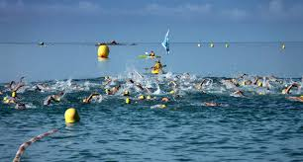

So where are these percentage improvements in your swimming technique for open water?
1. Sighting and Navigation
Did you know that you can add 20% or more to your overall open water swim race distance by not sighting effectively or often enough? We often see GPS swim tracks where swimmers have gone further than they expected.

Sighting every 6-8 strokes and checking on your navigation reference regularly is important to swimming and sighting effectively, so you swim in a straight line. It’s best to sight on something higher like a darker tree, building, or spire, than a buoy in the water! Learning to sight efficiently while swimming in open water saves wasting time and energy.

1. Sight after you breathe, there’s more time for water to clear from your goggles, thus improving visibility, and less drag from pulling your head directly forward out of the water.

2. Practice sighting off landmarks such as highly visible buildings or other structures on shore. In a race choose these beforehand while you’re warming up.

Practice sighting by turning your head slightly forward either before or after taking a breath. Sight after your breath, as there is more time for the water to clear your goggles, thus improving visibility, and less drag from pulling your head directly forward and out of the water. When sighting after a breath, you are also more likely to rely on peripheral vision, which will also reduce drag.

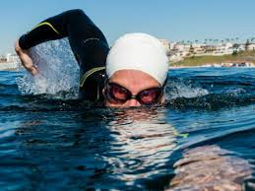

2. Pacing for Open Water Swim Racing – Sprinting and Threshold Efforts
As a triathletes or open water swimmer, should you sprint off the start line? You’ll produce high levels of lactic acid if you do, and may not recover for 10-15 minutes until your can swim at your target race pace again.
Try this swim session and see how you get on! It will make you as strong as an ox, and as fast as a cheetah in these positive split intervals.

Supersets x5
(swim a good warm up and cool down with this session).
These are very tough, be prepared to work very hard!!
5 x 150m as (50m front crawl flat out, then straight into 100m @80-85% effort) with 60 seconds rest at the end of each 150m.

Great swimmers have a variety of speeds, including warm up, aerobic training speeds, lactate speeds and pure print speeds. Having knowledge and an inherent feel for what these are will help you in swim races, and in particular knowing whether to sprint in mass starts.

By learning what your race pace is, and how to hold onto it, by making minor adjustments to your technique, drafting and sighting well, and navigating effectively, will all add up to the time savings we all know are there.
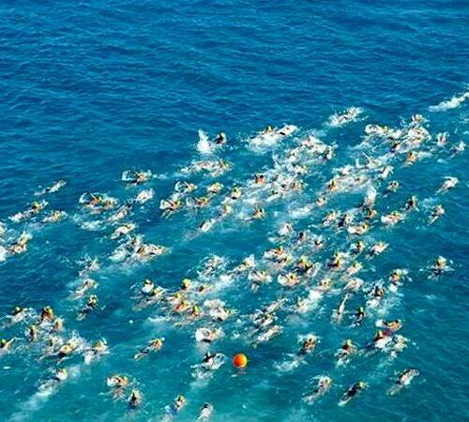
Can you do even splits +/- 3 seconds over 10-15x100m at race pace with 60 seconds rest? Work up to this, over a few weeks.
3. Technique for Turning around Buoys Effectively
Do you feel like you lose your way a bit when turning around buoys in open water, or when you're racing, are you filled with dread at the thought of being punched and kicked just as you’re about to breathe?

Try swimming slightly wider around the buoy away from the ‘corner’ where everyone tends to congregate. Practice turning around the ‘T’ at the end of the lane in the pool first, then progress to open water. You’ll need to sight straight after your turn to re-align with your navigation point ahead quickly.
Depending on the race course, you may end up performing up to 4 or 5 turns around a buoy or other non-moving object in the water. You should be practicing to use these pace changes to your advantage.
- Choose an object in the water to practice turns.
- When approaching the turn, you should transition to one-side-only breathing with every stroke.
- The side you breathe on needs to be facing whatever object you are turning around (another sighting drill).
- Try to cut the turn as close as possible, which may require you to use short, choppy strokes.
- Practice transitioning from a tight, choppy turn back into a long, relaxed glide, as you would do in the race.
- Go for 8-10 turn repeats.
Also practice doing ‘Crazy Ivan’ turnarounds in open water where you turn thought 360 degrees. Keep your strokes short and in the direction of your turn, keep kicking, and arc you body around the buoy. Over emphasizing the turn like this, makes it easier in a race, and is fun too!

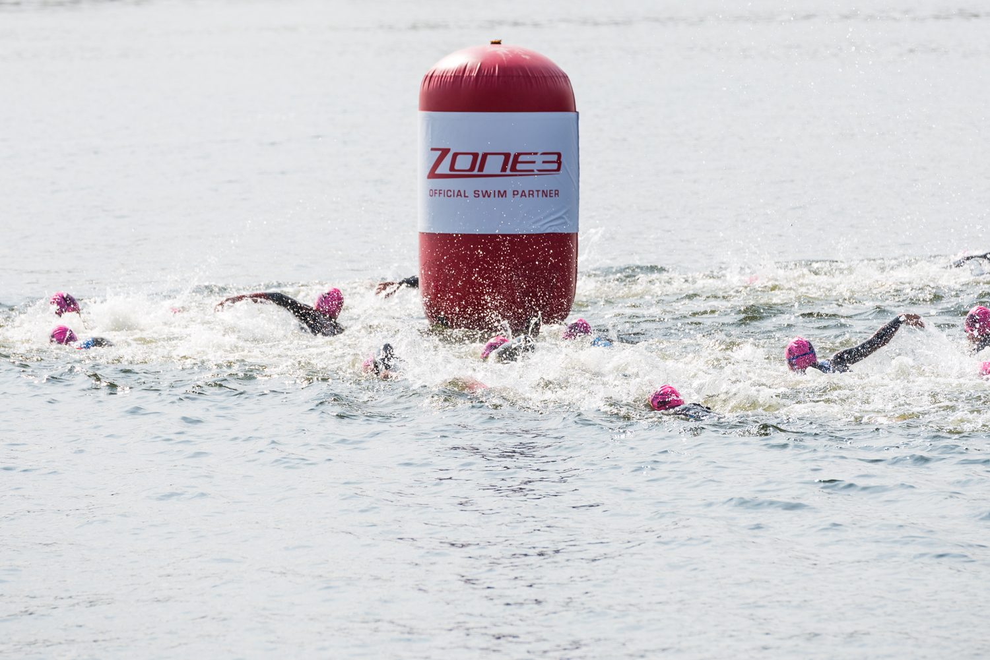

4. Drafting Techniques that Will Help Save You Time and Effort in a Race.
You could save as much as 18-25% energy swimming in open water by drafting efficiently and effectively. This means you could save up to 70 seconds over 1500m, or 3 minutes over 3.8km!

By swimming in someone’s wake that is slightly faster than you, you’ll save quite a bit of your energy in open water, enabling you to swim faster than you would normally. Practising swimming in close proximity to others will ensure you get used to this feeling.

There are 2 methods of drafting, one where you position yourself about 12 inches behind the swimmers feet, and the 2nd by swimming close to the lead swimmers hip. Make sure you keep sighting in each position. Don’t necessarily trust that the swimmer you’re drafting is navigating perfectly.

However, by drafting effectively, you can significantly reduce your oxygen uptake, heart rate, blood lactate, rate of perceived exertion, whilst stroke length is dramatically increased in the best drafting position.

5. Mass Starts Techniques
Does a feeling of panic start to overcome you when you think about open water mass starts? Follow these tips to help take away this fear…

Position yourself in the pack so you breathe towards the group. For example if you normally breathe in a race to your right, start on the far left hand side. This way you’ll be out of the melee of the main group, and in your own space more.

Lay / float horizontally in the water prior to the start so you can get the best send off when the gun goes. This also gives you more space around you than a deep water ‘legs down’ start position, limiting people swimming on top of your legs.

If you don't want to be a part of all those flying arms and legs, then plan your escape route before the race starts. Don't start in the middle of the front. Start at the back, where nobody else will really want your space in the water.
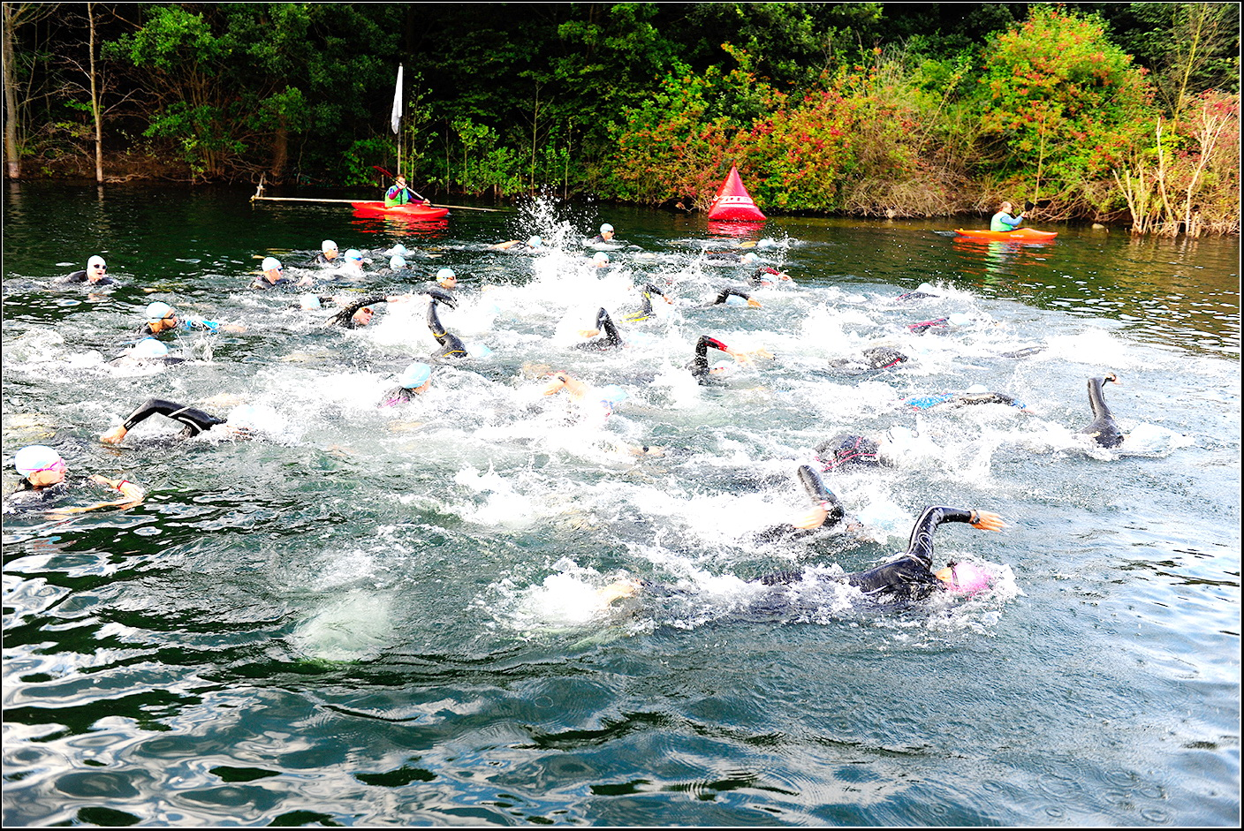

6. Adapting to Wetsuit Swimming

Swimming in a wetsuit can give you between a 7-10 second improvement over 100m than swimming without one. Also as you go higher up the product range, the available technology helps you to swim faster and stay more stable and higher in the water. This can be as much as 20-30 seconds over 400m, as you progress up a range of wetsuits (All tested with Race Zone 3 wetsuits)

Practising drills which make you feel slightly disorientated in the pool are very useful for distraction control and maintaining your rhythm and tempo when swimming in a race, and you’re getting bumped about by other triathletes swimming in close proximity to you.

We would recommend the following swim drills to help you get the most out of swimming in your wetsuit:

- Zips
- Turnarounds
- Barrelrolls and somersaults
- Eyes closed with sighting
- High elbow recovery

Zips | Slide your thumb up your side from hip to armpit | Promotes high elbow recovery
Barrel rolls | Whilst doing front crawl, keep kicking and rotate yourself 360 degrees mid stroke holding a lead arm in front for balance | Body roll and power in core /oblique’s Helps develop muscles used in rotation.
Turnarounds | Practice turning around the ‘T’ at the end of the lane in the pool first, then progress to open water. You’ll need to sight straight after your turn to re-align with your navigation point ahead quickly | Teaches you to do buoy turns effectively in open water. Try to make them as tight and fluid as possible.
Eyes closed swimming | Practice this in a pool, in the middle 10-15 metres of the lane close your eyes to see if you can stay swimming straight (only if no one else is swimming in the lane, or in an organised club session) | This shows you if your stroke pulls you to one side or is uneven, and you’re likely to do this in open water. If you do, sight more often every 6-8 strokes consistently.
Chicken wings | Touch your hands into your armpits | High elbow recovery
Somersault | Front somersault start I deep water, with 15 yards max effort, 35 yards easy. Repeat x6. 60 seconds rest | Good for distraction control and maintaining tempo / rhythm. These can be combined with barrelrolls for a real challenge to maintain our rhythm and tempo.

7. Sea Swimming
The sea can present many different challenges to your normal swim stroke. For example, in choppy water, if you keep your fingers just above the surface of the water, then you are quite likely to have an unexpected wave come along and cause your hand to enter the water below your shoulder. In order to allow a reasonable stroke, you need to have a much higher recovery with your hand in open water.

8. Top Tips for Sea Swimming

- Sighting in swell: You would have no doubt seen in the Olympics open water race, it a slightly different technique to sighting in flat water. Due to the size of the swell you’ll either need to lift your head higher, or sight on the crest of the wave. If it’s choppy be prepared to sight more, as the currents can move you around more than normal.

- Navigation: Sight on something that’s high if you can, or if swimming parallel to the beach, sight horizontally as well as forwards to maintain you position.

- Bilateral breathing: It’s recommended to be able to breathe bilaterally whilst swimming in the sea, for 2 reasons. One is for making sure you hold your position in a group and to make sure the currents are not moving you around too much, and 2, if you’re swimming a rectangular course and the swell is high, then sighting towards the beach going out and back, will stop you swallowing lots of water, if you’re breathing in towards a wave.
- Drafting in currents: If there is a current pulling you away from the first buoy, try angling yourself into the current more. So if the current pulls you to the right, swim more over to the left about 30 degrees, so you’ll then be drifting in an arc to the right spot to turn next to the buoy.

- Wading: Running in the water up to knee height, by flick your feet out laterally and your knees inward slightly, will help you to run and keep your feet clear of the sea water / waves. This is much quicker than swimming at this depth.

- Dolphining: To get past the breaking waves, its best to use a dolphining technique. This involves a mixture of a butterfly swim technique, with launching yourself into a dive, touching the sea bed / sand with your hands and then pushing yourself back up again into a dive. Only do this until the water is about waist deep, after this its best to start swimming normally.

- Beach starts: You can have a lot of fun with this next exercise as long as you have a safe beach entry for practice. Be sure to check for submerged objects that you might not have otherwise seen when entering for your warm-up. If you're with friends, divide yourself up into pairs and label yourself 1 and 2 whilst standing on the beach looking out to the water. Upon the command "Go!" attempt a safe beach entry into the open water using wading and porpoising skills. Once you are deep enough swim 40 strokes away from shore before turning and swimming back fast to the beach, making sure you avoid any head-on collisions with any other swimmers in the process. Run up onto the beach and tag your partner. Let them do the same - 40 strokes - before you take over again and then each do 30 strokes, then 20 strokes, then 10 strokes.

Paceline drafting | Complete a 200m circuit (1-2-3-4) where each of you and your friends perform one section (50m) on the front of the line, before peeling off to the back of the line. Do this first exercise steadily and controlled with 2 or 3 friends and tune into how much easier it feels to sit behind someone.
Arrow head Power drafting | Arrange a group of 4 swimmers into a diamond shape pattern, using the principles of ‘Arrow Head Drafting’ as per the video, i.e. 1 swimmer at the front setting the pace, 2 swimmers either side only breathing in towards the lead swimmer and the final swimmer sandwiched in at the back, gaining most draft.  Perform either a 200m circuit swapping the orientation of your 4 swimmers in a clockwise fashion every 50m or a 400m circuit swapping every 100m.  Work here as a team, working at the pace of the slowest swimmer at each point.
Deep water starts pool | As a group, line up between TB 1 & 4 facing towards TB 2 & 3. Tread water for ~10-15 seconds as though waiting for the start of a race. Select someone to shout "Go!" and swim briskly straight forwards to between TB 2 & 3 (50m).  Perform this exercise 4 to 6 times, gradually making the start ‘area’ narrower and narrower (possibly with the use of the kayakers, if you have, to ‘shepherd’ the swimmers) to generate a growing sense of claustrophobia which often accompanies tight race starts!

Conclusion

By applying these small 1% gains from every aspect of your swimming stroke and technique, they can all add up to something fundamentally larger than the original whole you once knew as your swimming stroke! Let’s see how much we can help you improve your swimming technique and fitness over the next few months, so you can have the best swimming season yet!

Using rotation and anti-rotational exercises to develop more power and speed in your front crawl swim stroke

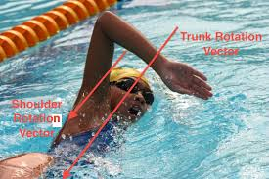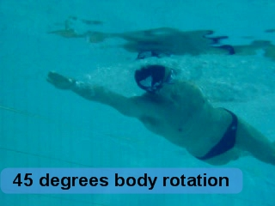

This is a guide to core-driven rotational swimming. Powerful, efficient, and injury-free, it's a much better way to swim with greater speed. It's how advanced swimmers swim. It's how you should swim. It's not hard to do, once you understand a few simple ideas.
Newton’s third law of motion states that: For every action there is an equal and opposite reaction.
So if your hand goes beyond the centre line or outside of the tube you’re effectively swimming in, your core needs to try and counter act this excessive movement. The opposite effect would be your legs and body snaking, causing un-necessary turbulence around you, and thereby increasing drag in the water. This would make it harder to maintain your forward driven rotational swimming motion.
Bernoulli’s law states that to go twice as fast in water you need to expend 4 times the amount of energy.
As humans we can’t sustain this for long, elite swimmers can swim at about 4 mph, age group swimmers swim generally- about 2-3mph. So we need to learn how to utilise the water to our best advantage, and engage our core and rotational muscles. For example, our internal and external oblique’s need to generate and harness the power from rotation to propel ourselves forwards whilst minimising any excess sideways motion.
If you want to swim well, then this is what you need to do.
Each stroke, every part of each stroke, is all about balance. Your torso must balance without the aid of your arms and legs, otherwise energy that should be used to move forward will be lost through stabilizing your body. It's repetition of simple practice drills that develops good balance. We still need to practice long axis rotation of the body, whilst trying to swim in a tube of water just outside the width of your body and arms as they bend to 90 degrees in the pull phase of the stroke. There is a gyroscopic feel to swimming, and the more you reach outside of the tube the harder it is to pull it back together. This is where a strong core can help control and counter act these rotational forces and harness them more into forward momentum.
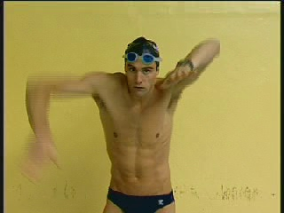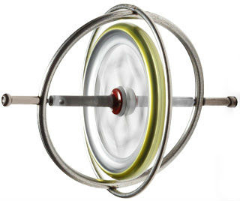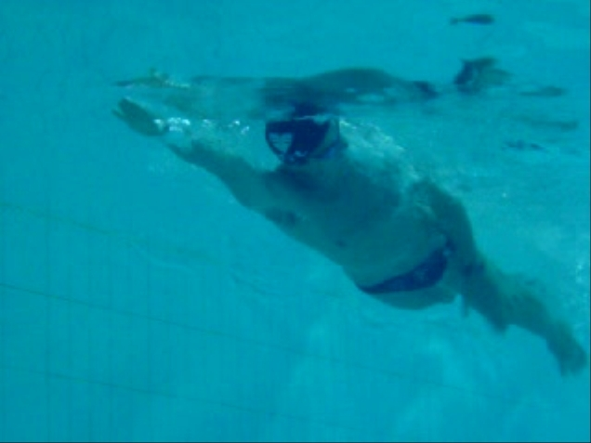

All athletic movements involve a rotational component, either, creating twisting movements through concentric muscular contractions (baseball swing, shot put) or, resisting rotational movements/stabilizing the torso through isometric holding contractions. The ability to concurrently generate and transfer power in the torso originates from the core. The core includes the muscles of the abdominals, lower back, pelvic floor and hips. In the simplest terms: rotational training = core training.
Rotating the body is very important, as is reducing drag, and being as streamlined as possible. Do we just rotate for that reason alone? If we did, kicking on our side would be faster, whether underwater or on the surface, than kicking on our stomach, and there is not much difference in speed either way. Besides that, we really spend very little time completely on our sides whilst swimming front crawl. Most of it is in transition from one side to the other and closer to horizontal than vertical. Finishing a front crawl race in a pool or lake on our side is also important, because we can extend our reach further, not reduce drag.

So if body rotation is not about drag reduction, why do we do it?
There are two reasons:
- The first is to gain more power. By rotating, we put our arm into a biomechanically better position of strength, engaging much bigger muscles in our back and core to help with the pulling phase of the stroke.
- The second reason has to do with the counter-rotation. When we enter our right hand in the water, for example, our body is rotating to the left. At the very moment we begin our catch, the body has stopped rotating left and initiates the counter-rotation back to the right. We call this point the connection (between arm and core/hips). This counter rotation creates a stabilizing force that gives us something to pull against.
Remember, it is you and the water molecules out there…no walls, or starting blocks to push off or pull against. So we have to create our own stabilizing force out of the rotational motion of our own body. The faster and longer the counter-rotational turn, the greater the stabilizing force and the better distance per stroke (DPS) we can achieve.
In other words, we are no longer pulling against just water molecules that are relatively motionless. We now have the water, plus whatever force we can generate with the counter-rotation of our body. The amount of that force that we get to pull against is related to our mass (weight) and to the angular velocity of our body’s rotation (how fast we rotate).
Basically, as your left arm is pulling back and your left shoulder is digging down and back, your right arm is swinging up and your right shoulder is coming up and forward. That opposition gives the right side of your body some forward momentum, taking some of the weight of your body off of the water held by your left arm. If all of your weight is being applied only to the water, your hand will slip back through the water more instead of anchoring and pushing the body forward from that anchor. By giving the body more forward momentum at the same time as it applies force backward, we get more out of that pull since the hand will catch and anchor better.
Also, think about the third law. If we have good opposition, timing, and connection between the shoulders then the upward and forward motion of the right arm, while not inherently propulsive, would add force to the backward motion of the left arm (equal in magnitude, opposite in direction). Think about what it’s like when you pull into the wall hard in a pool, and then push hard off it with your feet. If you barely pull yourself into the wall, then it’s hard to push back out hard. Every action needs an equal and opposite reaction. Balance these two out and there’s more power available!
The rotation of the body doesn’t just happen. A swimmer has to make it happen and that requires a lot of core strength and work. When the rotation is fast and well timed, it is worth the effort, creating a substantial force that enables the swimmer to cover more distance with each stroke.
Life and sport require that we be able to both control and produce rotational force. Anti-rotation training utilizes the same asymmetrical loading we encounter every day. Whether you're carrying groceries, picking up your child, throwing a ball, or performing athletic movements such as swimming, running, and cycling, your body is always producing rotation or controlling externally-induced rotation.
So how does this all translate to swimming and how can we learn to apply it to front crawl?
By engaging your core muscles in counter rotation before actually rotating in a 45 degree bodyroll they create a strong base to rotate off, and therefore you’ll experience less snaking and wasted energy in relation to Newton’s third law of motion, i.e. every action has an equal and opposite reaction. What we’re trying to do here is harness the energy, as it has to go somewhere, and its best utilised and contained within the muscles of your core from counter rotating your body. This enables you to generate more forward momentum and power in your swim stroke.
To see this in action more watch this video..
Future dreams video of Haydn Woolley rotating well https://www.youtube.com/watch?v=6jv4px4rp6Q
Rip training video
https://www.youtube.com/watch?v=84ms0ItkwgA
There are some great drills to help you learn to use your body effectively when you swim. One of my favourites is the 3 stroke 6 kick drills where you hold one hand over your head and the other at your side with the head down. Kick for 6, then do 3 strokes and rotate to the other side in the same position to repeat.

These core strength exercises will give you greater propensity upon which to pull and push against as you rotate with more control, speed and power.

- Exercises to strengthen your core and oblique’s for improving your rotation for swimming:
Perform 12-15 repetitions of each exercise for 2 sets with 30 seconds rest between each set, 2-3 times a week for best results
- Rip rotation
  - Stand sideways to the anchor with your feet in a parallel stance
  - Rotate your hips, spine and shoulders as a "cylinder" away from the anchor point, while holding the bar perpendicular to your body
  - Control the recoil allowing your "cylinder" to rotate back toward the anchor
  - Repeat with an aggressive concentric contraction and a slow and controlled eccentric contraction back toward the anchor
- Lower body twist
  - knees 90 to 135 to 180 degrees (straight) controlling eccentric and concentric rotation
  - Lying on your back with your legs raised and knees to 90 degrees initially, arms outstretched in a T in line with your shoulders.
  - Decelerate your legs down to one side, and then with a controlled movement take them over to the over side
  - To progress try straightening your legs more and more keeping your thigh stacked over your hips
- V sit twist with a medicine ball
  - With your knees bent to 45 degrees, engage your core and lean back to about 30 degrees. Keep your back straight and long
  - Using a 3-5kg medicine ball rotate the ball from the floor by one hip over to the other side and back
  - To progress either speed up the movement under control or use a slightly heavier medicine ball
- Static cable band / hold at 90 degrees to anchor point. This is an anti rotation exercise, training your core to resist rotation
  - Using a bungee, theraband, cable machine or Rip Trainer hold the handle at chest height with a light weight (for cable machine)
  - With your feet slightly wider than shoulder width apart, and your arms straight out in front of you at shoulder height
  - Grasp the cable handle with both hands directly in front of your chest.
  - Keeping your core tight, extend your arms in front of your chest. Bring your hands to your chest to return to the starting position
  - With your body perpendicular to the resistance hold the cable / band whilst trying to resist being rotated back
  - Hold for 10-30 seconds each side

- Squat and reverse wood chop with a medicine ball
  - Holding a 3-5kg medicine ball close into your body, stand with your feet shoulder width apart
  - Keeping your knees behind your toes, back straight, core engaged and chest lifted, perform a squat whilst moving the medicine ball down to one foot
  - Using your oblique’s then straighten your arms as you stand back up and take the ball across your body in a diagonal motion from your feet, finishing to the outside of your shoulder
  - Decelerate the opposite movement back down to your feet
Disclaimer: You should make sure you see a physical therapist prior to completing these exercises, especially if you have a pre existing injury

Swim Drills to aid and improve Rotation

Rotational balance kicking 4 quarters | This drill starts on the Side, and both arms stay at the Sides  The Head Drops under in both Side positions, and 'pops' back up on both the Front and the Back  Breathing through the 4 positions = Hold, Hold, Hold then Blow just as you start to rotate to the Back | AIMS to teach the difference between all the Four possible Balance positions in the water
6 kick 3 stroke changeover | Breathe only once after each 3rd stroke, then drop back into your side-kick position for another 6 kicks...  Keep finding your correct Side Balance point immediately after each stroke & breath, and stay kicking in balance for at least 6 kicks before stroking again | AIMS are to help with balance and facilitate better body rotation from your trunk.
Barrel rolls | Whilst doing front crawl, keep kicking and rotate yourself 360 degrees mid stroke holding a lead arm in front for balance | Body roll and power in core /oblique’s Helps develop muscles used in rotation
Bodyroll | Performing normal front crawl, rotate from the hips to 45 degrees each side | Minimises frontal area resistance, making you more streamlined

Abbreviations

FC = front crawl
BC = back crawl
BR = breast stroke

CSS = Critical swim speed

TT = time trial
T pace = same as CSS

RI = rest interval

IM = individual medley = butterfly stroke, back stroke, breast stroke, front crawl

Pull = pull buoy

Nick de Meyer is the author of Speedy Freestyle, a front crawl swim drills book, and he is a level 3 British Triathlon Coach. He has been the head coach for Phoenix Triathlon Club in Guildford, Surrey. He is currently the head coach for Surrey University Triathlon Team, and head coach for Speedy Swimming.

He is also a level 3 Personal Trainer and a Master Endurance Coach with Training Bible Coaching UK. He is an open water swimming coach and teaches at Shepperton Open Water Swimming Lake. He has completed 2 Ironman Triathlons, and the Dart 10km swim to name a couple and has been training competing and coaching triathlons for 20 years.

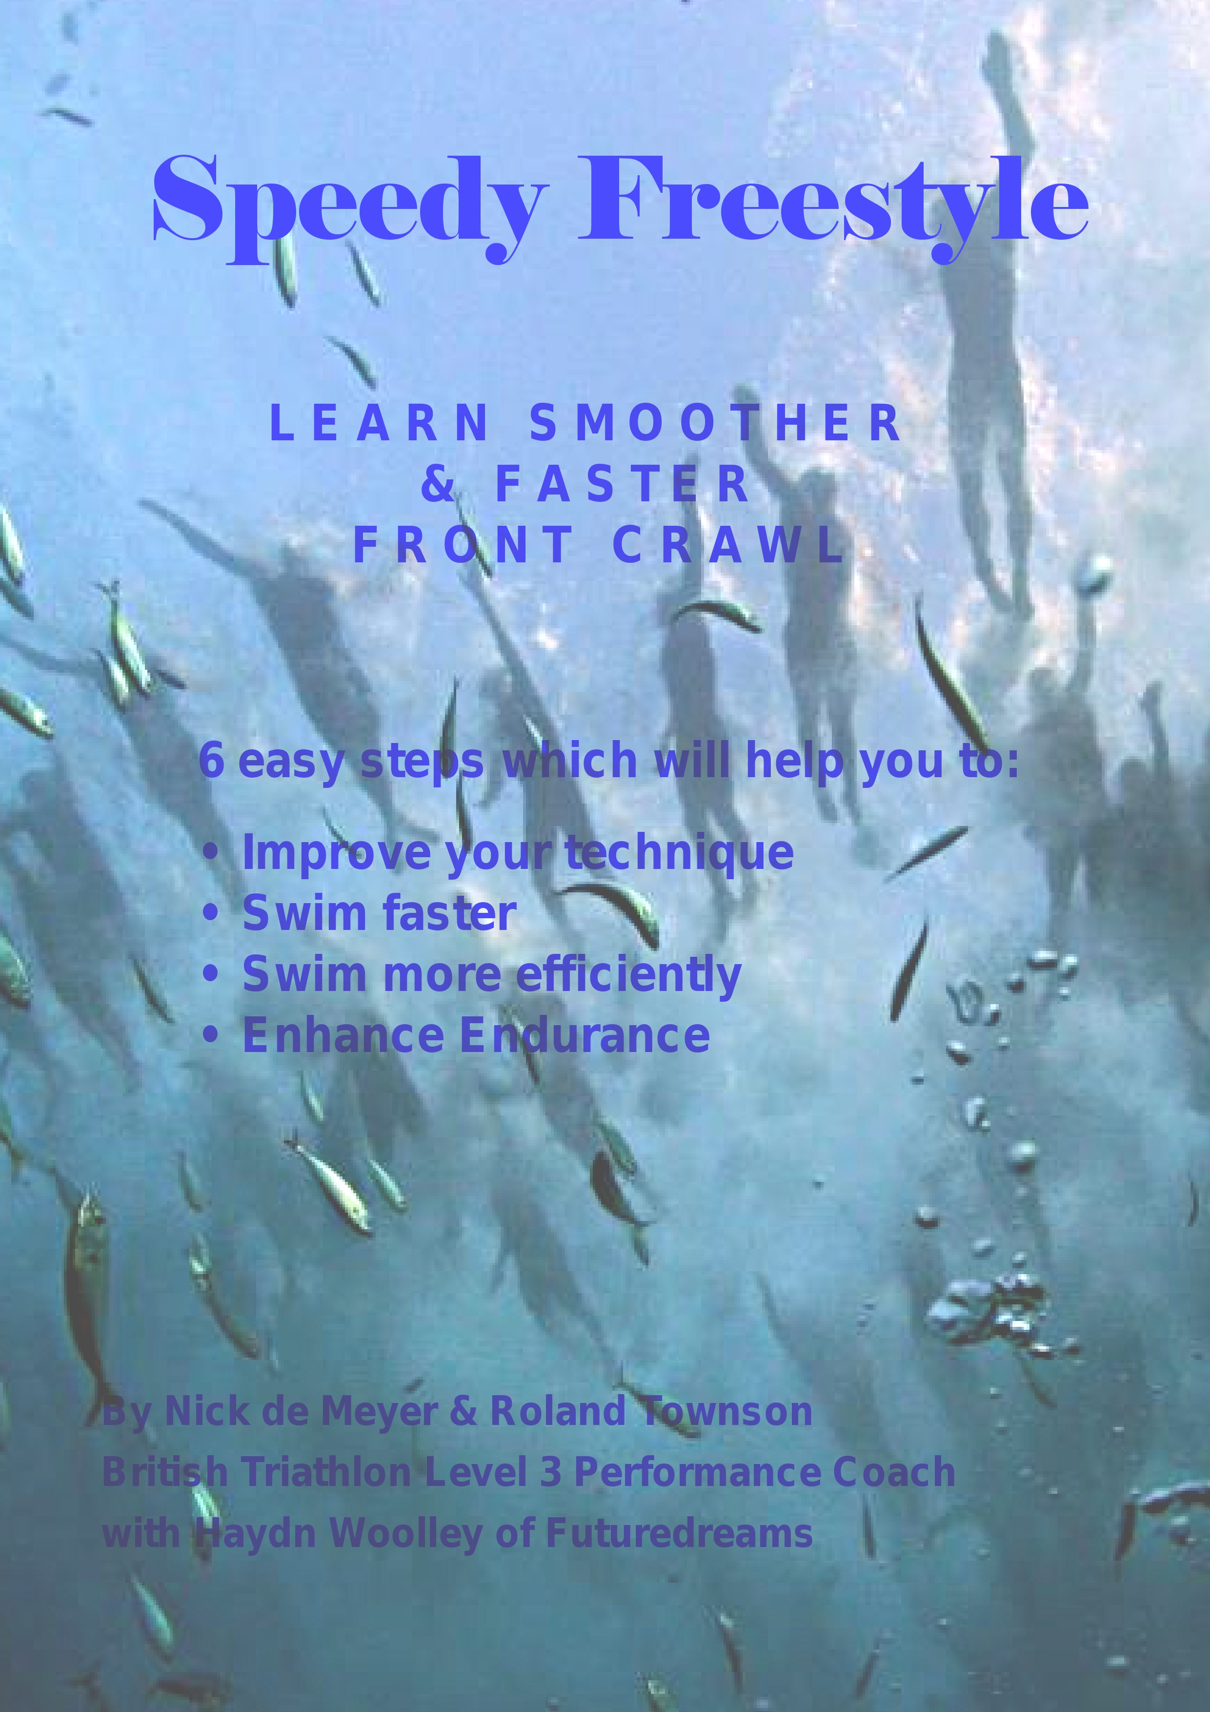
www.speedyswimmming.co.uk
speedyswimming@gmail.com

